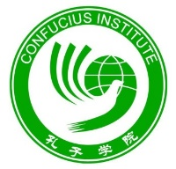

Registration Form
- for Students

Windsor Court
42-44 Great North Road
Newcastle University
NE2 4HE
Email: confuciusinstitute@newcastle.ac.uk
na.yao@newcastle.ac.uk

Registration Details

Name
Gender
Date of Birth
Email
Telephone
Address
Chinese Learning Background (e.g. Beginners’/one year’s learning experience/etc).
Medical conditions/disabilities or special needs you would like us to be aware of
Emergency contact name and number
Preferred time slots:  (Please select your preferred time and feel free to offer any other slots that suit you better) | 2023 July  2023 August  2023 September  2024 Easter Holiday  Other (please specify): _________

If you have any questions or concerns, please feel free to contact us.

